(Approx. 918 words)

Get Around Quickly in Word Documents
By Nancy DeMarte, 1st Vice President, Sarasota Technology User Group, FL
March 2015 issue, Sarasota Technology Monitor
www.thestug.org
ndemarte (at) Verizon.net

Do you write multipage documents or ones based on an outline? Do you save them from other sources? If so, you should get familiar with a helpful feature that was introduced with Office 2010 and refined in Office 2013 - the Navigation Pane. This tool helps you move quickly from one part of a document to another, reorganize sections without cutting and pasting, and find nearly anything in the document.

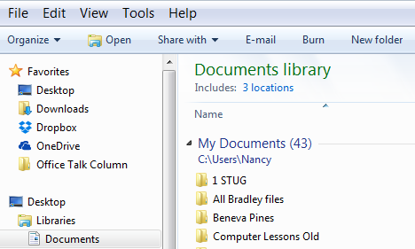
This sort of navigation is not new. Windows Vista, 7, and 8 users are familiar with the Navigation pane that sits on the left edge of the Explorer window (shown), giving easy access to anywhere on the computer with one click – Favorites, Desktop, Libraries, etc. This concept is now part of many Office applications. In Word 2013, it offers all kinds of assistance with multipage documents.
Figure 1 Navigation Pane in Windows 7

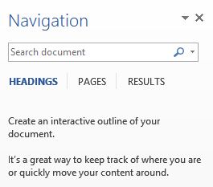
To view this feature in Word 2010, either click the View tab on the ribbon and check Navigation Pane or press Ctrl + F on the keyboard. In Word 2013, you can also click the page count on the left end of the status bar along the bottom of the window. The Navigation Pane appears in the area left of the document window, displaying a Search box above three tabs.
Figure 1 Navigation Pane in Word 2013

Let’s explore the tabs:
The Headings tab (Figure 2) lets you move around quickly in a document which contains headings. To use the time-saving Headings feature, you must have applied one of the Word Heading styles to the headings in the document. The Styles Gallery is found on Word’s Home tab. To apply a style, an easy way is to use Format Painter (Home tab – Clipboard group). Select the first heading in the document and click the Heading 1 style. Then select that heading again, double click Format Painter, and click each succeeding heading. They will become the Heading 1 style.

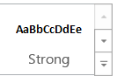
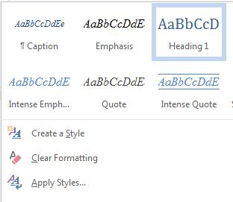
If you wish, you can also create a new style for headings and save it to the gallery. To do so, click the down arrow with a line over it in the bottom right corner of the Styles gallery and choose “Create a Style.” In the dialog box, name your style and choose a font, size, color, or other options. Click Save and your new heading style will appear in the Styles gallery.
Figure 3 Styles Gallery in Word
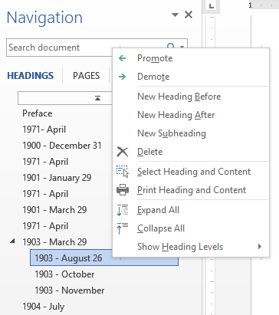
Clicking the Headings tab displays a list of only the document’s headings, as in Figure 4, giving you an outline of the document’s structure. Clicking a heading opens that section in the document window. You can reorganize sections by dragging a heading to a new spot; all its related text moves with it. Other actions become available if you right click a heading, as shown. You can add a section in the middle of the document, for example, by choosing “New Heading Before (or After)” or turn a heading into a sub-heading by clicking “Demote.” “Promote” reverses the move. The “Collapse all” command is used to hide sub-headings so you can work only with the main headings in the document. “Expand all” returns them to the list. Clicking the small up arrow in the center above the first heading (shown) jumps you back to the beginning of the document. Think how useful this could be for editing a 50+ page document.
Figure 4 Headings tab and menu

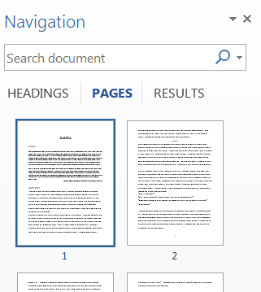
The Pages tab displays numbered thumbnails of all the pages in the document, a handy way to move around a document or check page layout in a document with graphics. Selecting one of the thumbnails opens it in the document window. Scrolling through the thumbnails to find a page near the end of a long document is much quicker than scrolling through each page. But if you do scroll through the document, the Pages tab will highlight the thumbnail of the page you are viewing.
Figure 5 Pages tab
This aspect of the Navigation Pane has been part of the PowerPoint program through several versions. In Office 2013, it is found not only in Word and PowerPoint, but also in Publisher and Outlook.
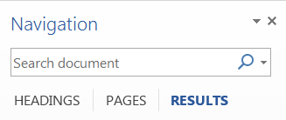
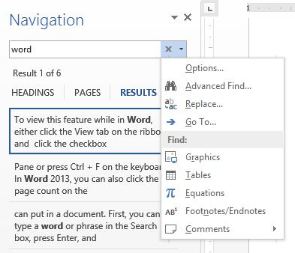
The Results tab serves several important functions. The Search box at the top lets you find almost anything you can put in a document. When you type a word or phrase in the Search box, all instances of the word will be listed with their surrounding text, as shown in Figure 6, and also will be highlighted in the document.
Figure 7 Search tool for objects
Figure 6 Results tab and menu

To search for photos, drawings, tables, objects, equations, and footnotes, click the magnifying glass inside the Search box (Figure 7) and make your choice. To move through the search results, use the up and down arrows to the right of the Results number (hidden behind the menu in Figure 6).

The Find and Replace feature, found on the Home tab in many versions of Word, has also been conveniently included among the Navigation Pane options. To use it, click the small down arrow next to the magnifying glass in the Search box (Figure 7). Click Options to refine your word search; click Advanced Find to open the Find and Replace dialog box. As you use the Word Navigation pane, you will find it houses a wealth of helpful tools.

